**Power BI Dashboard Funky Maake**

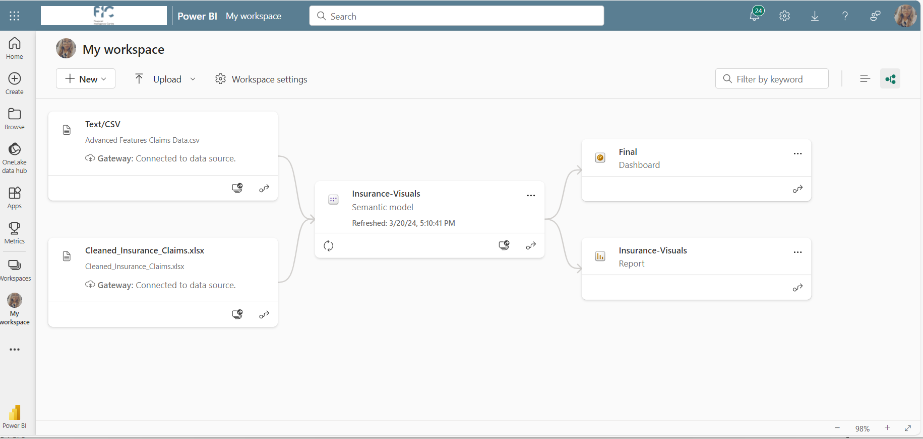

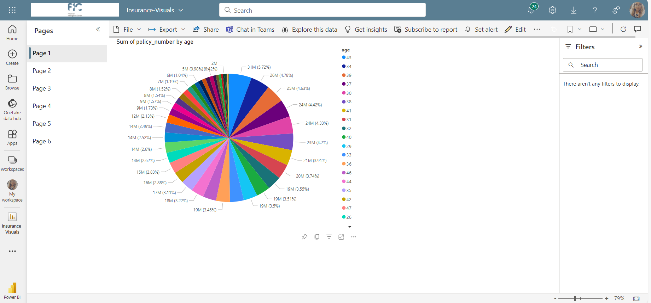

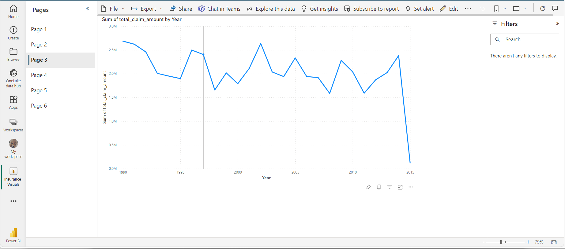

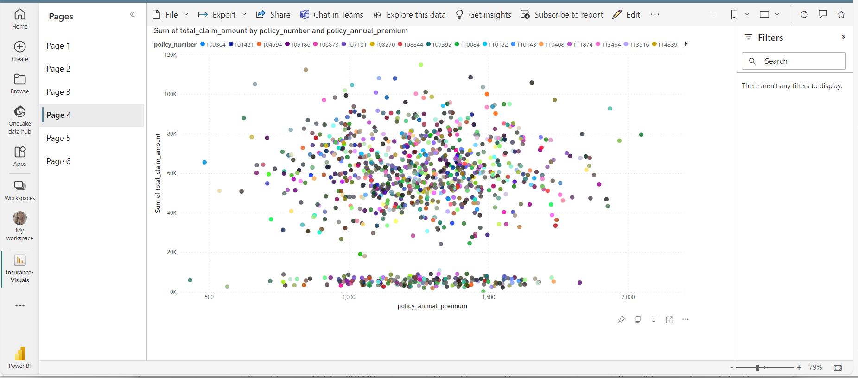

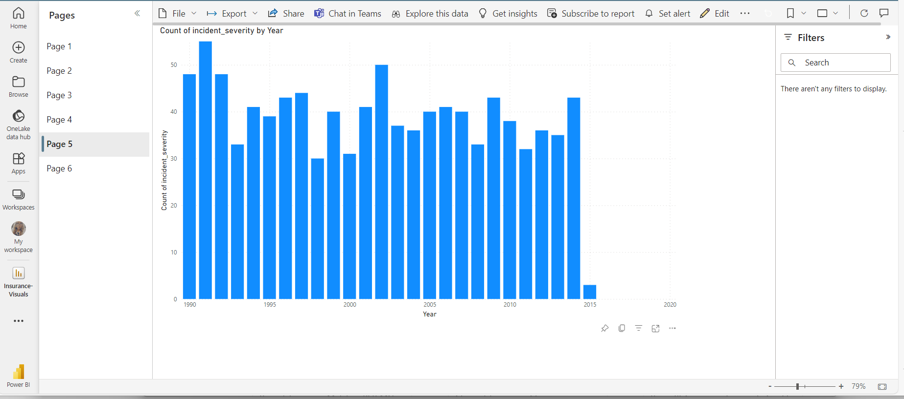

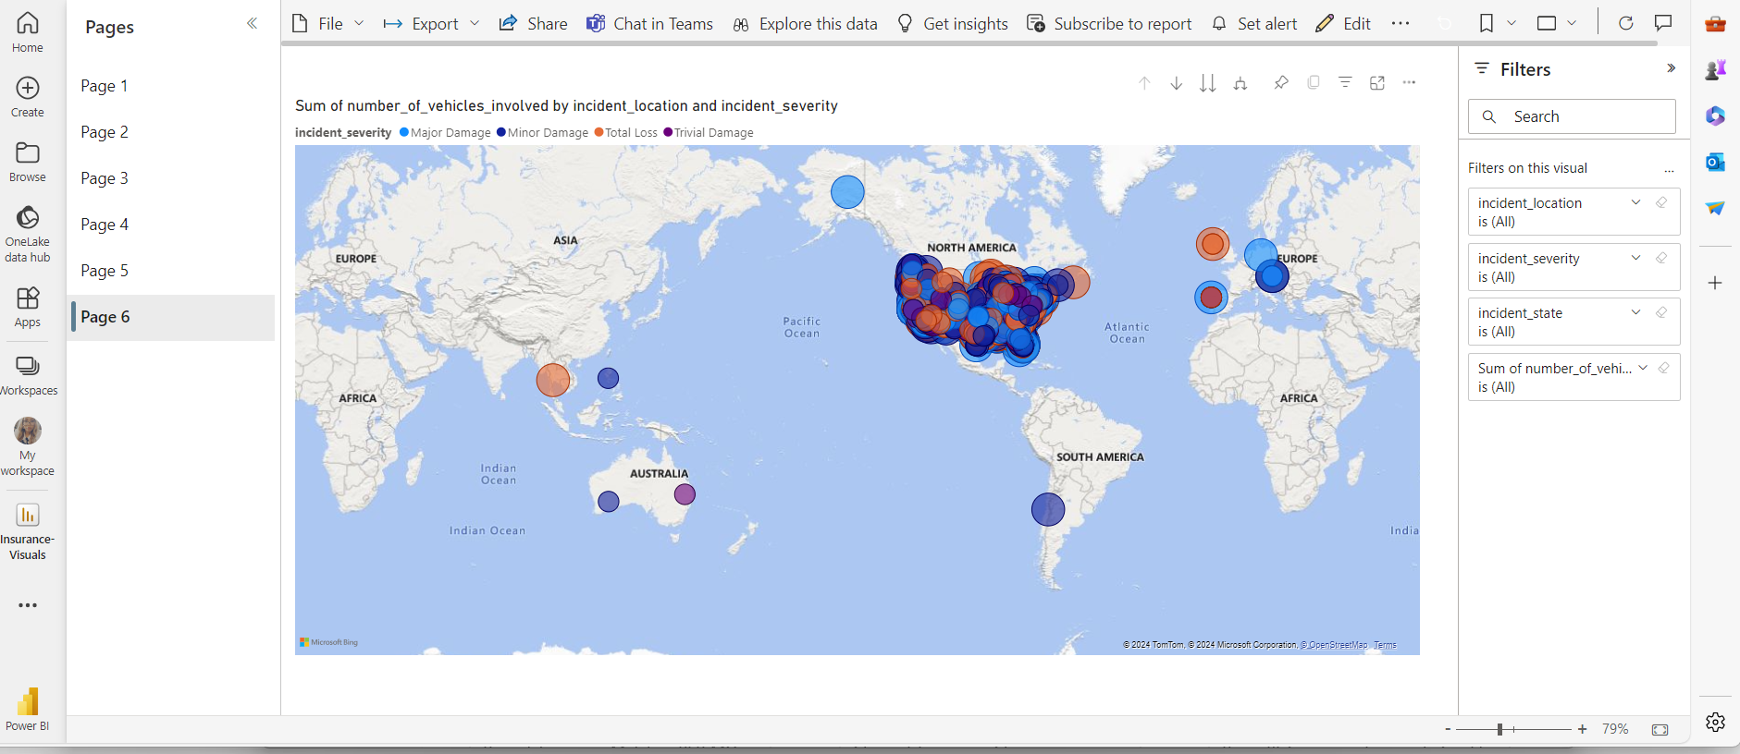

Quick Insights for Insurance-Visuals



